電通二乙微處理器實驗 實驗結報

實驗名稱 | I2C通訊
組別 | 16 | 組員 | 曹允誠

- 實驗目的
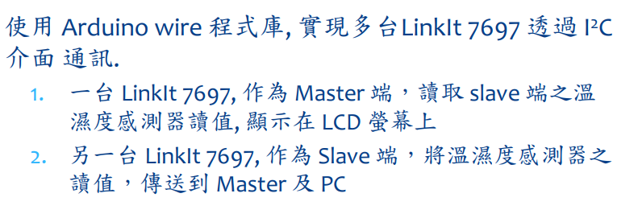
- 實驗步驟
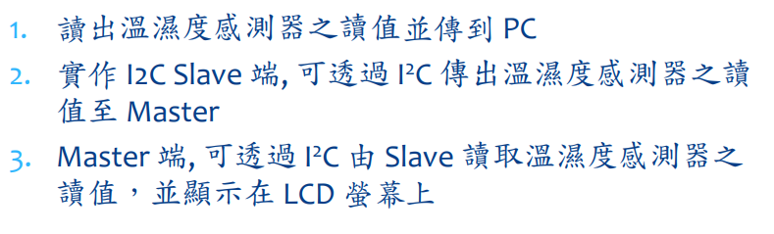
- 程式碼
#include "DHT.h"
#define DHTPIN 2
#define DHTTYPE DHT11

DHT dht(DHTPIN, DHTTYPE);

void setup() {
Serial.begin(9600);
Serial.println("DHT11 test!");
dht.begin();
}

void loop() {
delay(2000);
float h = dht.readHumidity();
float t = dht.readTemperature();
//float f = dht.readTemperature(true);
/* if (isnan(h) || isnan(t) || isnan(f)) {
Serial.println("Failed to read from DHT sensor!");
return;
}*/
if (isnan(h) || isnan(t)) {
Serial.println("Failed to read from DHT sensor!");
return;
}
Serial.print("Humidity: ");
Serial.print(h);
Serial.print("%\t");
Serial.print("Temperature: ");
Serial.print(t);
Serial.println("*C\t");
// Serial.print(f);
//Serial.print("*F\n");
}
- 實驗結果及分析
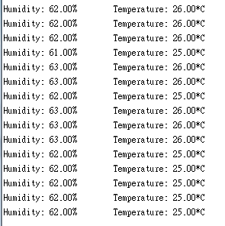
- 心得討論
- 修正電路圖
- 修正程式碼

